**Hardware Review 2**

**ME 486C - FanFlyer**

**Faculty Advisor: Dr. Trevas**

**Technical Advisor: Brandon Begay**

**Client: Jim Corning**

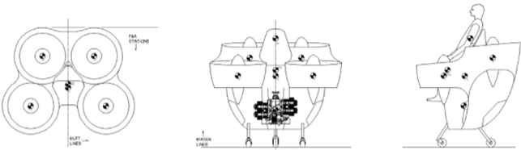

Fan Flyer team members

Steve Sorden

Travis Byakeddy

Corey Marcum

Nathaniel Schaul

Progress summary & update since Hardware 1

Since Hardware Report (HR) 1 a few changes have surfaced with the frame designs and methods of analysis. Final frame concepts per member have been generated and shared with the client with whom, as of the submission date of this report, have yet to receive feedback from. In large part, much of the client’s physical decisions have not deviated. Certain purchased parts are still being waiting on before the finalization of some parts of the flyer can be produced. But as of the date of this submission, nothing has been largely produced as of yet.

Motor

The motor is still the same, however, it does possess a few extensions to connect to the rotor shaft drives, however they are only cabling and wires.

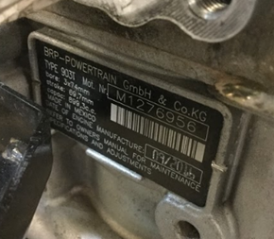

Figure 1: BRP- Powertrain motor

FanFlyer Modeling

The Flyer shell is the same as of the last client meeting and HR 1. No holes or modifications have been cut into the Flyer shell yet until a final frame has been decided.

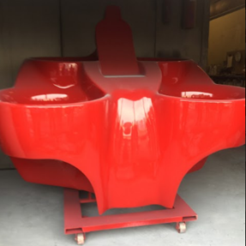

Figure 2: Fanflyer shell

Finite Element Analysis

The members of the team that are enrolled in ME 454 - Finite Element Analysis, have attempted to transfer CAD files of multiple frame designs over to the ANSYS APDL version. However, errors and warnings of the transfer have occurred that need to be reviewed and corrected before this can be performed. Some CAD files also need to be re-drawn because the meshing of some designs is not supported because of small geometry augmentations and cause errors in the simulation meshings.

Frame Designs & Concepts

Four frame proposal ideas from each member have been generated since the last HR. The drawings of which can be viewed in Figures 3, 5, 7, and 9, below. Figures 4, 6, 8, and 10, accompany each of their respective drawings in relation to the clients provided Flyer shell, which can be seen below each of the Frame drawings. Each frame encompasses the newly updated client requirements of possessing a type of roll cage, seven-point rear support, and support for a ballistics parachute.

Concept 1

Along with integrating the client’s updates, this proposal is rated to withstand the maximum thrust output that each rotor can achieve, while also being able to bear a total weight of 1,500 lbs pulling downward. Where each of the horizontal shelving units was simulated to support 500 lbs each.

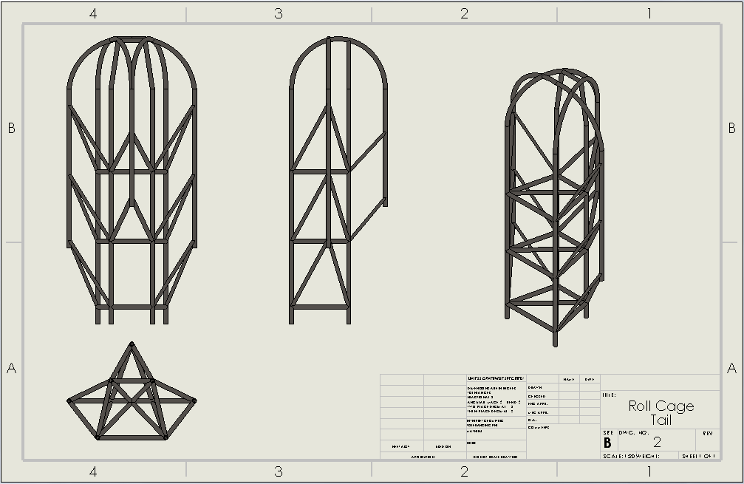

Figure 3: Updated Frame Design Concept 1

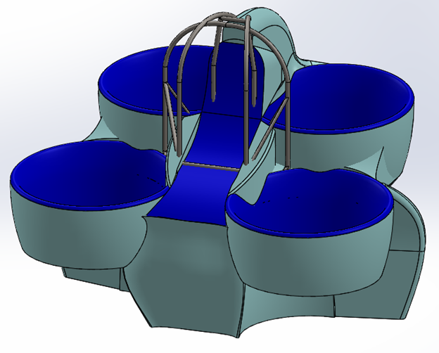

Figure 4: Concept 1 Flyer

Concept 2

This concept was created based on the new client design for seven points of contact. The design goal of this frame was primarily to give the pilot more room, which was a priority of the client from previous frames. The design accomplishes this by opening the sides of the frame so that it isn’t as cramped. Additionally, the top is left open above the head of the pilot for less vision obstruction during flight. The side supports still go more than halfway up the sides in order to continue to support the structure laterally. The design also incorporates an additional support in the back. This support doesn’t provide much strength to the overall structure of the frame but is mainly for the ballistics parachute to mount to. The base of the design is open for the motor placement and additionally allows freedom for mounts.

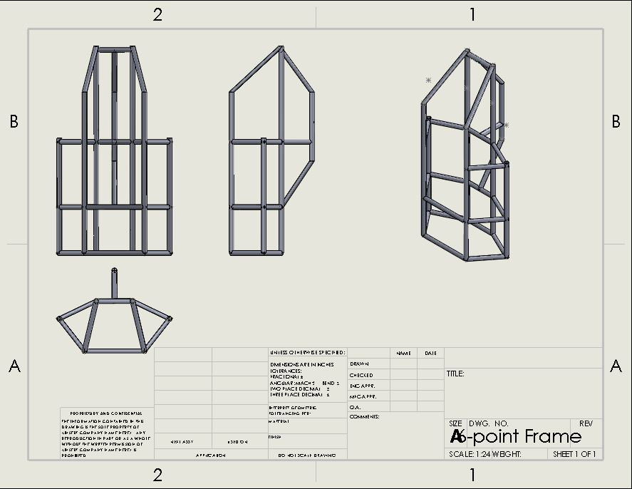

Figure 5: Updated Frame Design Concept 2

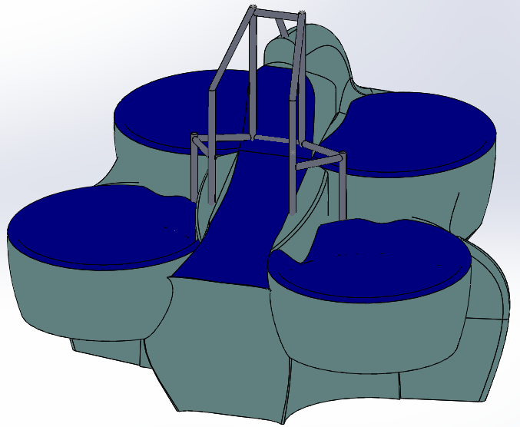

Figure 6: Concept 2 Flyer

Concept 3

The design in figure 7 is based off one of the original designs proposed to the client in HR 1 only with an added roll cage. There is a seven-point contact system that stays mostly inside the frame and has open space inside the frame for the motor and rotors. The roll cage is open at the front in order for easy pilot seating. The cage is designed for the pilot to use a safety buckle to remain in the seat and the roll cage is designed to prevent the pilot from being directly injured by a crash while allowing an easy seating. Figure 8 is what the design would look like in the FanFlyer Shell shown in figure 2.

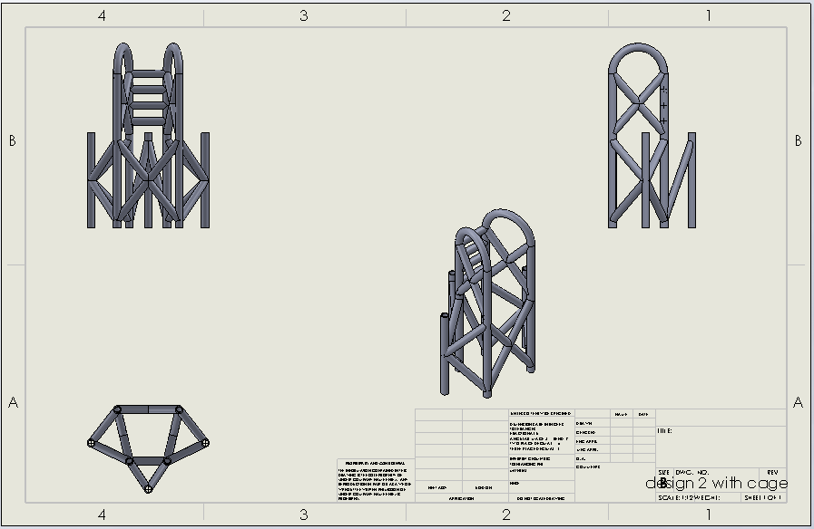

Figure 7: Updated Frame Design concept 3

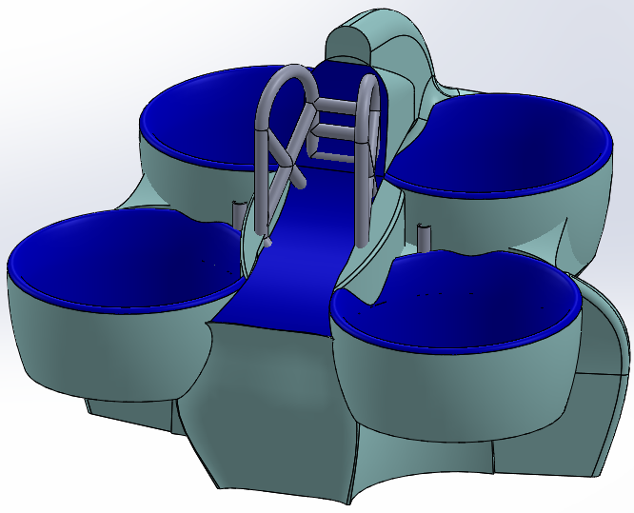

Figure 8: Concept 3 Flyer

Concept 4

This concept is a derivative of the original design for the frame the team proposed to the client in HR 1. It implicates the seven-points of contact system the client requested and offers a lightweight and stable design. The main issue from the previous frame was there not being enough space for the pilot. So for this concept, the top of the frame is far more open to leave more room for the pilot. This concept also incorporates the support in the back to hold the parachute system the client wants to implement into the quadcopter.

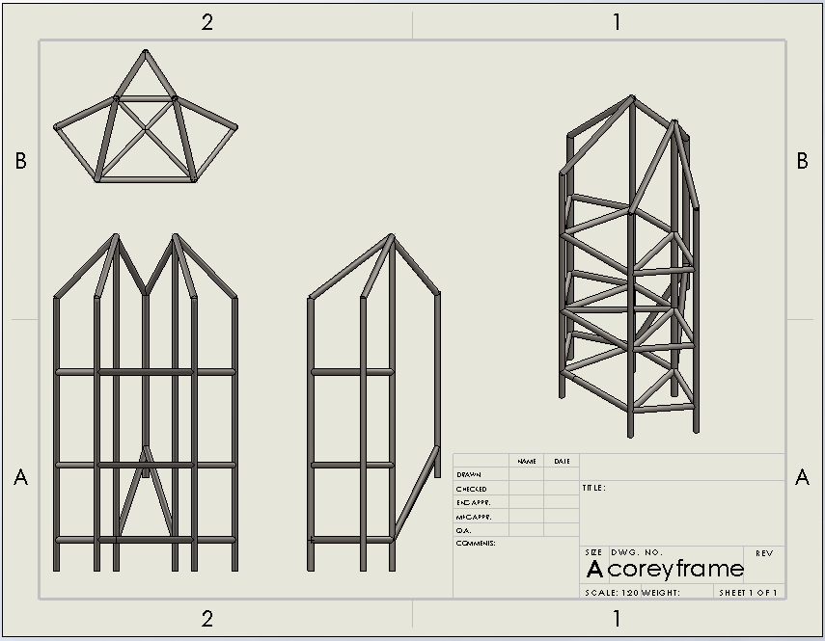

Figure 9: Updated Frame Design concept 4

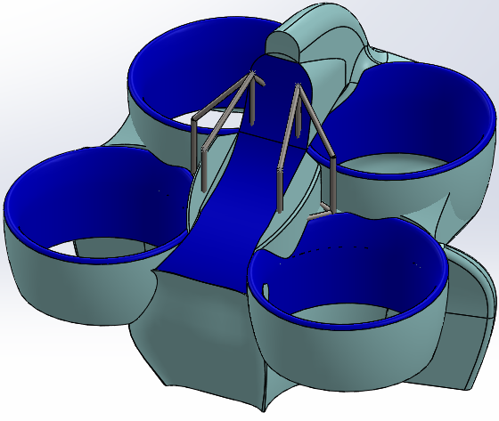

FIgure 10: Concept 4 Flyer

Material Analysis

Since HR 1, the team constructed an analysis of different materials that could be used as a substitute for the client recommended 4130 Steel. From the analysis, the team has learned that the best option for a material substitute would be 7075 T-6 Aluminum. This material was chosen because it offers a weight reduction of approximately one-third while retaining a similar yield strength. The only issue with choosing to proceed with this material substitute would be that it would add an increase in material cost by approximately three and a half times that of the 4130 steel. Because of these pro’s and con’s it is a proposal the team administered for the client's approval. At this time the client has not responded whether this will be the option moving forward. All this analysis can be observed in the tables below.

Table 1: Materials Properties to Determine Price Per Weight [1] [2] [3] [4]

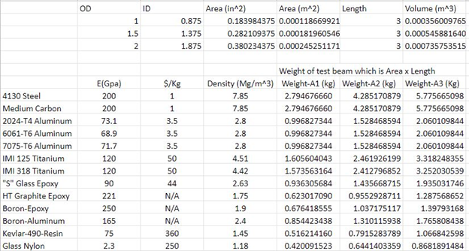

Table 2: Materials stress and deformation [1] [5] [6] [7]

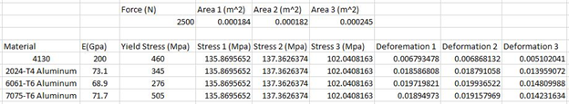

ANSYS Frame Analysis

Moment Forces

A recalculation of the moment forces magnitudes, directions, and locations was required to provide a proper ANSYS analysis considering the client’s seven-point frame desire. Figure 11 shows the direction and magnitudes of said moment forces. Figures 12 and 13 show the physical locations of where these moment forces are located in relation to the Flyer. Figure 14 shows the moment angles and source distance that each force from Figure 11 is located at and from. The cylinders and circles in all four figures represent the center locations of the four rotors.

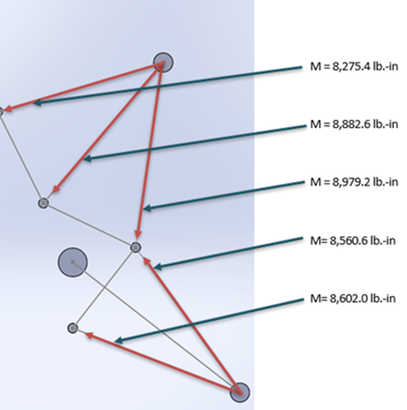 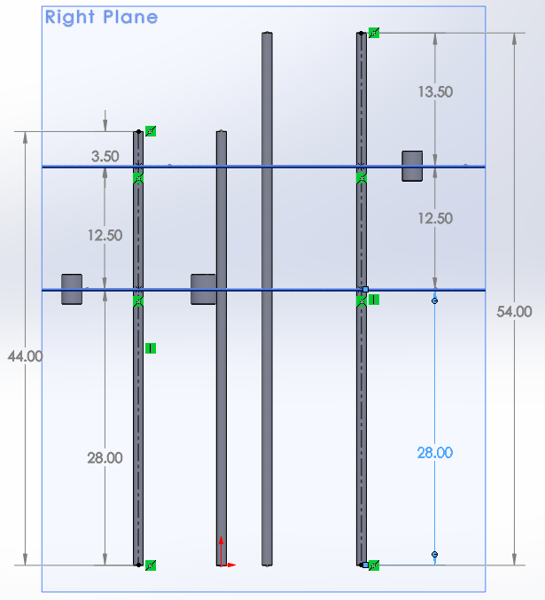 Figure 11: Magnitudes & Direction Figure 12: Vertical Moment Locations

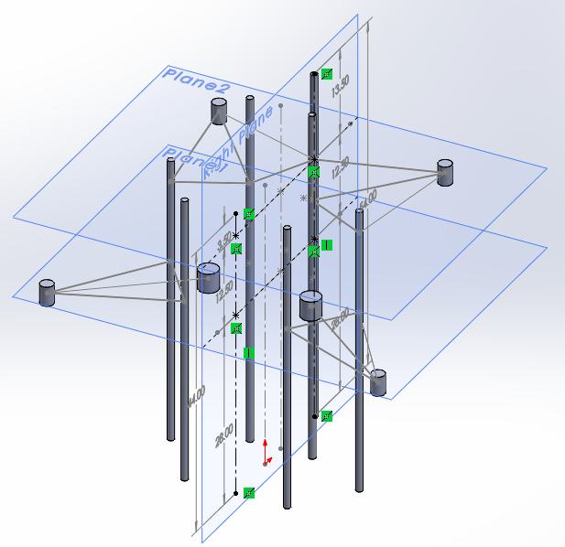 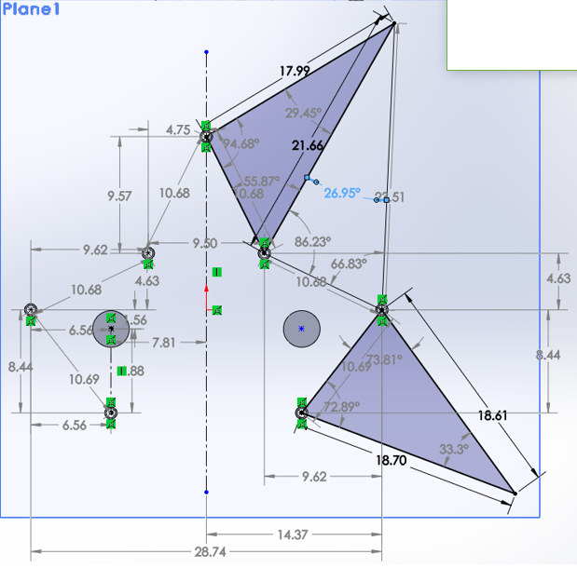

Figure 13: Dymetric Moment Locations Figure 14: Moment angles

Fixpoint Discussions

At the onset and conclusion of HR 1, the placement of the ANSYS workbench fixed points was not yet discussed and was misunderstood. Figure 15 illustrates the multi-point application and Figure 16 shows the resulting condition. Where all the vertical members of the frame experience no moment forces despite their apparent presence, indicated by the red circular arrows of Figure 15. A team discussion concluded that it was best to select one fixed point for an ANSYS analysis resulting in Figures 17, 18, and 19 for discussion, where the red arrows in the left of the images represent the imposed gravity (linear) and moment (circular) forces on the frame.

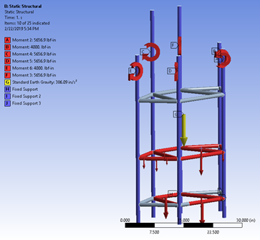 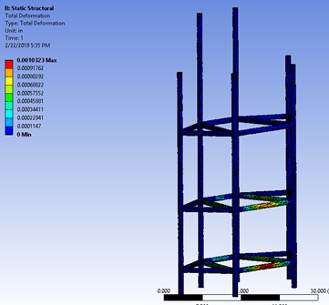

Figure 15: Multiple Fixed points Figure 16: Multi-point result

Figures 17, 18, and 19 each show the various deformation effects as it pertains to the locations of the set fixed point which is highlighted in blue for the center frames of Figures 17, 18, and 19. As noted in all three cases the area of high concern is that of the top portion (roll cage) of the frame, because in each case the roll cage aspect of each simulation results in the highest chance of deformation regardless of fixed points.

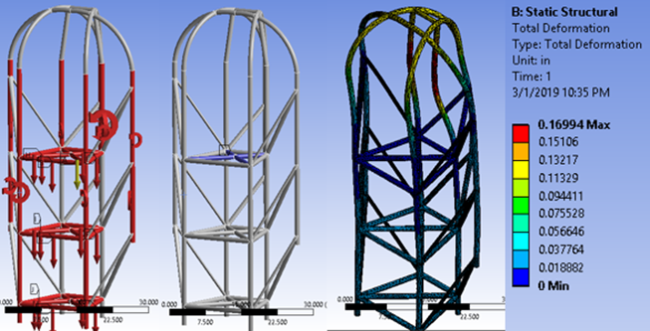

Figure 17: Forces, Center Fixed point (Blue), **Deformation**. (All one image)

Figure 17 shows the deformation simulation with the fixed point at the center of the frame. It was decided as a team that this would be the bassline of all forgoing simulations because that top horizontal cross beam portion of the frame is very close to the center of mass of the frame. So it stands to reason that this should be where the fixed point of the ANSYS simulations should be because in theory the center of mass is where the pilot should sit for the Flyer to remain balanced.

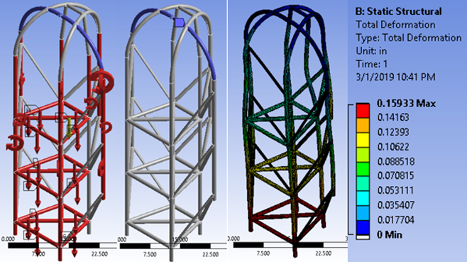

Figure 18: Forces, Fixed Top location (Blue), **Deformation**. (All one image)

Figure 18 shows the the deformation simulation where the fixed point is at the top of the roll cage. Despite this fixed location point not being the most logical, it can be seen that the design of the bottom half of the frame is durable enough to withstand the large amount of forces represented in the far left of Figure 18.

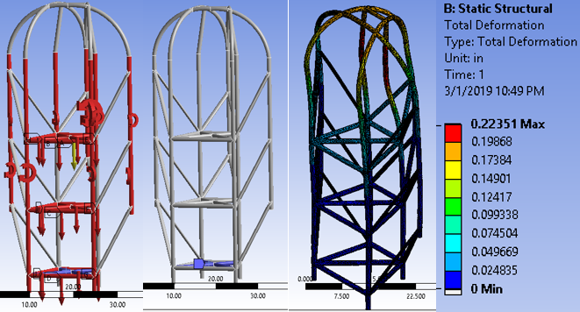

Figure 19: Forces, Fixed Bottom location (Blue), **Deformation**. (All one image)

Figure 19 shows the deformation simulations with the fixed point at the bottom. There is little that is worthy of note in this simulation. Figure 20 is the corresponding stress and strain results of Figure 17 above with the fixed point located at the center.

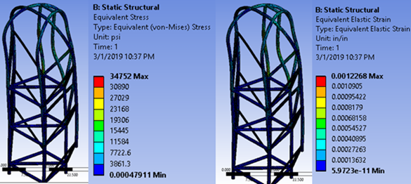

Figure 20: Stress and Strain with the Fixed point at the center (One image)

Hand Calculations

Evolving from utilizing simple vector applications in HR 1 that be be seen in Figure 21 and 22, the following hand calculations in Figures 23, and 24 were performed. These not only calculated the deflections of a simply supported beam for two different materials, but they could also be used to calculate stresses and strains in a much more complex system based on finite matrix math. Once the team hears back from the client about the design proposals, the team can begin analysis of their frame using these FEA hand calculations.

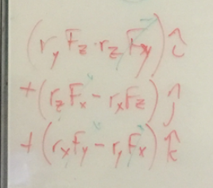 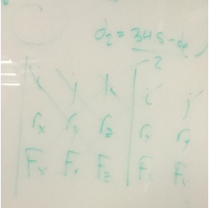

Figure 21: Rotor Moment Equations Figure 22: Cross Multiplication Process

Figure 23: FEA Hand Calculations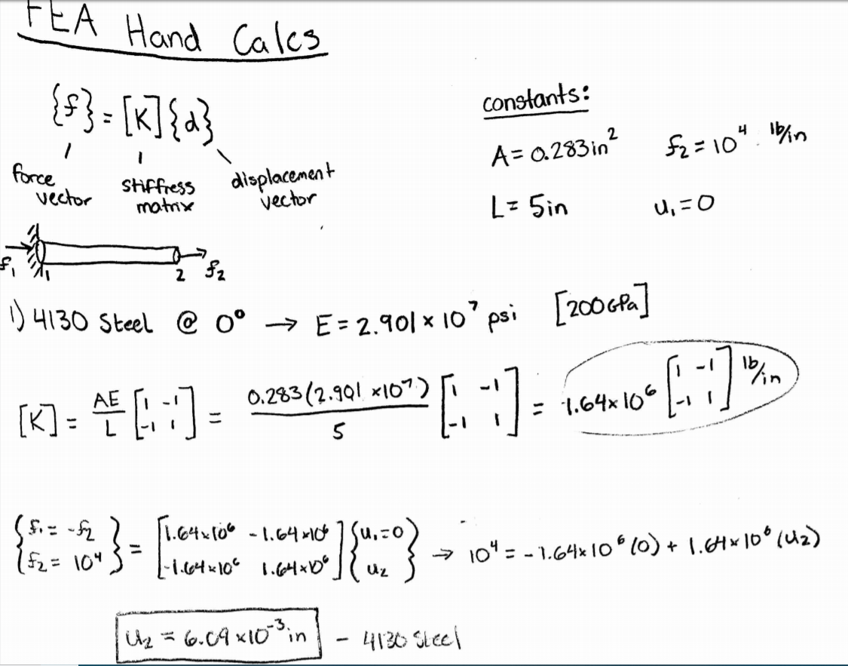

Figure 24: FEA Hand Calculations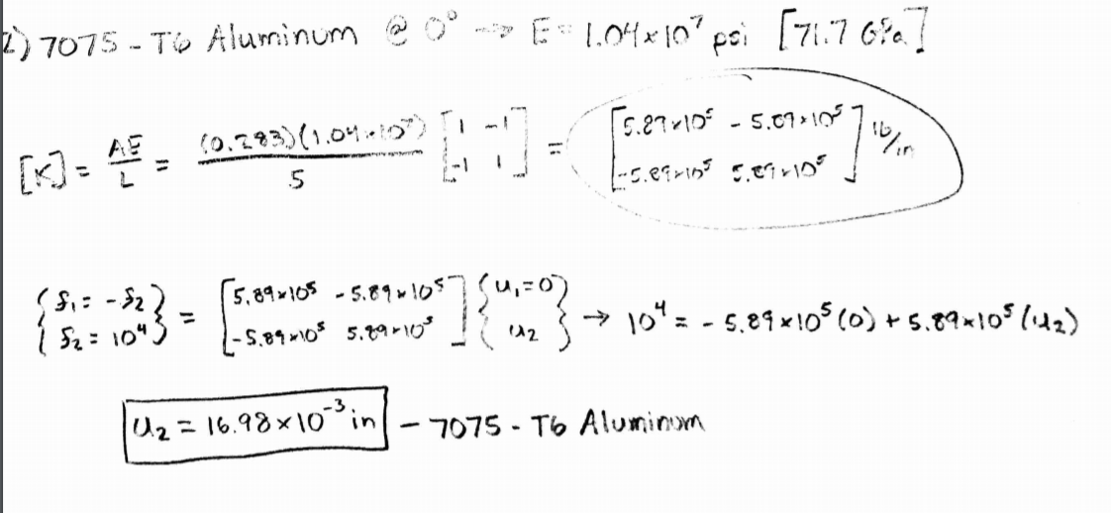

**Remaining actions and work(Moving Forward)**

The action items that the team will need to address moving forward before the final are as follows. The team will need to address any concerns that the client has with any of the proposed frames. Additionally, the team will need to analyze the frames in ANSYS workbench to see where there are potential areas of failure. The models will also need to be analyzed with the client recommended 4130 steel, and then compared with 7075 T-6 aluminum to back-up the theory that the aluminum will be a suitable material substitute for the frame. The team will need to verify the simulated answers using closed form hand calculations of the force analysis. Lastly, 3D printed models of the frames will need to be generated for presentations and for Ugrads.

References

|  |  |
| --- | --- |
| [1] | A. Cantrell, T. Stoebe, K. Firdaus, R. Oakes and J. Sines, "Bicycle Materials Case Study," 12 June 2003. [Online]. Available: https://depts.washington.edu/matseed/mse_resources/Webpage/Bicycle/Bicycle%20Materials%20Case%20Study.htm. [Accessed 1 March 2019]. |
| [2] | B. VanDragt, S. Defever, K. Brandenberg, R. Herman, J. Doezema, S. Oram, W. Faust and M. Saltzgaber, "Michigan State University College of Engineering," Michigan State University, [Online]. Available: http://www.egr.msu.edu/msm/dept/KWON/. [Accessed 1 March 2019]. |
| [3] | TTI, "TTIinc," TTI, [Online]. Available: https://www.ttiinc.com/content/ttiinc/en/resources/tools/material-costs.html. [Accessed 1 March 2019]. |
| [4] | "Fiber Reinforced Composites," Altair, 7 March 2016. [Online]. Available: https://altairenlighten.com/in-depth/fiber-reinforced-composites/. [Accessed 1 March 2019]. |

|  |  |
| --- | --- |
| [5] | AZO Materials, "Aisi 4130 Alloy Steel," AZO Materials, 12 November 2012. [Online]. Available: https://www.azom.com/article.aspx?ArticleID=6742. [Accessed 1 March 2019]. |
| [6] | AmesWeb, "Aluminum Alloys- UYield Strength and Tensile Strength," [Online]. Available: https://www.amesweb.info/Materials/Aluminum-Yield-Tensile-Strength.aspx. [Accessed 1 March 2019]. |
| [7] | J. Callister.W.D, in *Materials Science and Engineering:An Introduction 7th edition*, John Wiley &Sons, Inc., 2007. |